PRE-SCAN CHECKLIST

Name: ____________________________________________________________________________________ Date: ____________________
Your nervous system controls and regulates every cell of your body. We use state of the art technology
that reveals how well your nervous system is working.
Please let us know if we need to be mindful of the following:
 | Drinking coffee or tea can excite the nervous system. How many of these caffeinated beverages have you had today?
 | Yes | How many? ______ |  | No
 | Soda drinks can contain caffeine and chemicals that can affect the nervous system. Have you had any soda’s today?
 | Yes | How many? ______ |  | No
 | Nicotine is a nervous system stimulant. Have you used any tobacco today?
 | Yes | How many? ______ |  | No
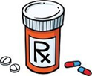 | Many prescription drugs and muscle relaxers affect the nervous system. Have you taken any type of prescription medication today?
 | Yes | What kind? ______ | How Much? ______ | No
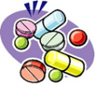 | Common over-the-counter drugs can impact the nervous system. Have you taken any of these types of drugs today?
 | Yes | What kind? ______ | How Much? ______ | No
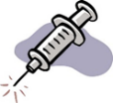 | Vaccinations/Immunizations affect the nervous system. Have you had any vaccinations within the past 14 days?
 | Yes | Which ones? ______ |  | No
 | Excessive exposure to the sun affects the accuracy of your scan. Have you had a sunburn in the last 5 days?
 | Yes |  | No
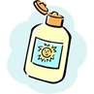 | Bath salts, oils or sunscreen on your skin can influence instrument sensitivity. Have you used any of these products today?
 | Yes |  | No
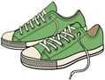 | Vigorous physical activity can exaggerate your scan results. Have you had a workout today?
 | Yes |  | No
Stress, depression, anxiety or emotional upsets can affect your nervous system tension.
Compared to a typical day, are you currently experiencing an increased level of stress?
 | Yes |  | No

